Cooking Ingenieros

Requirement Report

Author: <Author name>

Revision: 0.1

|  |  |
| --- | --- |
| NA |  |
| NA | Date: junio 08, 2018 |

**Revision History**

|  |  |  |  |
| --- | --- | --- | --- |
| **Revision** | **Date** | **Reason For Changes** | **Author** |
| 1.0 | Jan 02, 1990 | <Release> | <Author Name> |
| 0.1 | Jan 01, 1990 | <Initial draft> | <Author Name> |
|  |  |  |  |

**Table of Contents**

Microsoft Word users please click here and press F9 to create Table of Contents.

OpenOffice.org users please remove this text and select Insert Table of Content from menu.

**Table of Figures**

Microsoft Word users please click here and press F9 to create Table of Contents.

OpenOffice.org users please remove this text and select Insert Table of Content from menu.

**Executive Summary**

This section previews the main points of a report. The executive summary contains enough information for a reader to get familiarized with what is discussed in the full report without having to read it.

# Introduction

## Purpose

<This document provides requirements with their properties including requirement id, requirement name, requirement text and the dependencies.>

## Scope

<Provide a short description of the system being specified and its purpose, including relevant benefits, objectives, and goals.>

## Overview

<Describe what the document contains and explain how the document is organized>

# Your Requirements Project

## 1 Business requirements

### BR-1 Business requirement1

The system shall do term1

**customNumberingData:**

Multi-levelɲɪɳtrueɲɪɳfalseɲɪɳBR-ɲɪɳɲɪɳ3ɲɪɳ_17_0_4beta_1b3a0482_1355297412593_609711_22854ɲɪɳ_11_5EAPbeta_be00301_1147873236436_846958_2313ɲɪɳ_11_5EAPbeta_be00301_1147873190330_159934_2220ɲɪɳtrue

#### BR-1.1 Business requirement2

The system shall do term2

**Derived:**

|  |  |
| --- | --- |
| 1522929456.png | FR-1.1 Busqueda |

**Traced From:**

|  |  |
| --- | --- |
| 1522929456.png | FR-1.1 Busqueda |

|  |  |
| --- | --- |
| -1273040900.png | Búsqueda |

#### BR-1.2 Business requirement3

The system shall do term2

**Derived:**

|  |  |
| --- | --- |
| 1522929456.png | FR-1.2 Comparticion |

**Traced From:**

|  |  |
| --- | --- |
| 1522929456.png | FR-1.2 Comparticion |

|  |  |
| --- | --- |
| -1273040900.png | Compartir ofertas |

|  |  |
| --- | --- |
| -1273040900.png | Añadir ofertas |

#### BR-1.3 Business requirement4

The system shall do term2

## 2 Domain model

## 3 System requirements

### 3.1 Functional requirements

#### FR-1 Registro

El sistema debe permitir el registro de un usuario o empresa.

**Refines:**

|  |  |
| --- | --- |
| -1273040900.png | Registro |

##### FR-1.1 Busqueda

El cliente debe poder buscar un producto en concreto.

**Derived From:**

|  |  |
| --- | --- |
| 1452777329.png | BR-1.1 Business requirement2 |

**Traced To:**

|  |  |
| --- | --- |
| 1452777329.png | BR-1.1 Business requirement2 |

**Refines:**

|  |  |
| --- | --- |
| -1273040900.png | Búsqueda |

##### FR-1.2 Comparticion

El cliente debería poder compartir una oferta.

**Derived From:**

|  |  |
| --- | --- |
| 1452777329.png | BR-1.2 Business requirement3 |

**Traced To:**

|  |  |
| --- | --- |
| 1452777329.png | BR-1.2 Business requirement3 |

**Refines:**

|  |  |
| --- | --- |
| -1273040900.png | Compartir ofertas |

##### FR-1.3 Adicion y Modificacion

La empresa debe poder añadir y modificar sus propias ofertas y productos en el sistema.

**Refines:**

|  |  |
| --- | --- |
| -1273040900.png | Añadir ofertas |

|  |  |
| --- | --- |
| -1273040900.png | Quitar ofertas |

|  |  |
| --- | --- |
| -1273040900.png | Quitar tienda |

##### FR-1.4 Valoracion

El cliente debería poder comentar y corroborar una oferta

**Refines:**

|  |  |
| --- | --- |
| -1273040900.png | Opinión ofertas / tienda |

|  |  |
| --- | --- |
| -1273040900.png | Quitar opinión |

|  |  |
| --- | --- |
| -1273040900.png | Quitar ofertas |

#### FR-2 Ordenacion

Los productos y las ofertas deben aparecer en un mapa o en una lista ordenados por cercania.

**Refines:**

|  |  |
| --- | --- |
| -1273040900.png | Búsqueda |

#### FR-3 Moderacion

Los moderadores pueden banear y modificar cualquier usuario y ofertas.

**Refines:**

|  |  |
| --- | --- |
| -1273040900.png | Quitar opinión |

|  |  |
| --- | --- |
| -1273040900.png | Quitar ofertas |

|  |  |
| --- | --- |
| -1273040900.png | Quitar tienda |

#### FR-4 Legitimidad

La creacion de una oferta debe ser acorde con la legitimidad de la tienda pertinente.

**Refines:**

|  |  |
| --- | --- |
| -1273040900.png | Añadir ofertas |

#### 3.1.1 Use cases

#### NA NA

#### NA NA

#### NA NA

Los productos y las ofertas deben aparecer en un mapa o en una lista ordenados por cercania.

#### NA NA

### 3.2 Non-functional requirements

#### NFR-1 Respuesta

La velocidad de respuesta del sistema debe de ser en tiempo real.

#### NFR-2 Conexion

El sistema debe tener conexion a Internet constante

#### NFR-3 Geolocalizacion

El sistema deberá utilizar la geolocalizacion del usurio.

#### NFR-4 Redireccionamiento

Las ofertas compartidas deberán ser redireccionadas direcamente a la APP.

#### NFR-5 Accesibilidad

El sistema debe ser accesible para usuarios de consumo.

#### NFR-6 Restrinccion

Los usuarios que no sean de la propia empresa tienen restringido aladir ofertas de esta misma.

## 4 Traceability

### 4.1 Coverage validation

# Appendix A: Diagram

## Business requirement diagram

NA

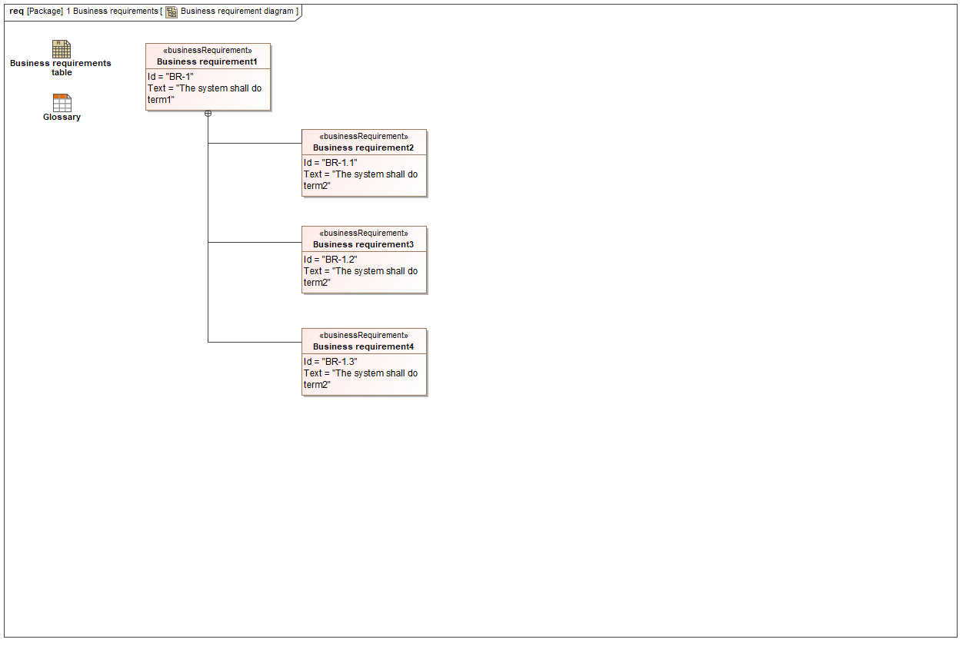

1. Business requirement diagram

## Business requirements table

NA

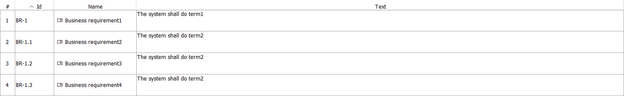

1. Business requirements table

## Derive FR and NFR from business requirements

NA

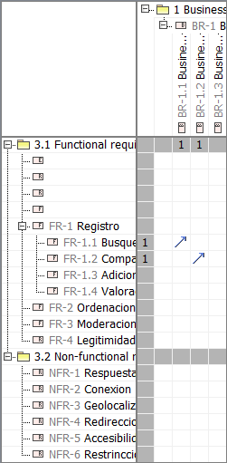

1. Derive FR and NFR from business requirements

## Diagrama de clase de diseño

NA

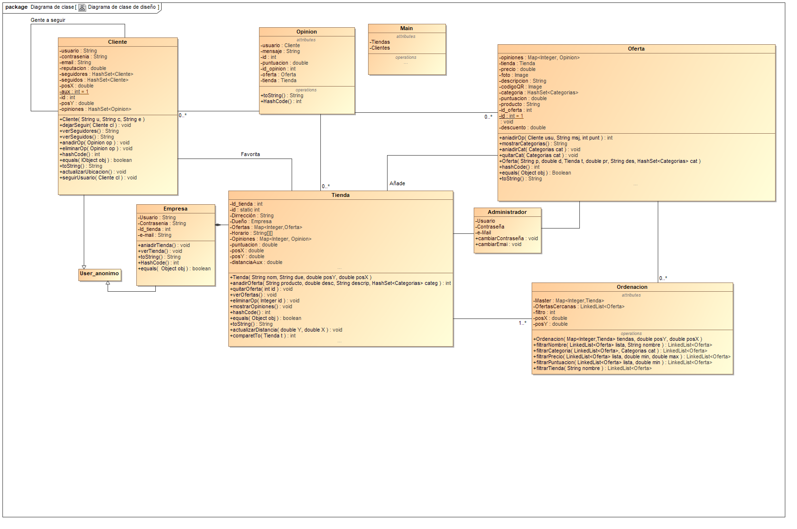

1. Diagrama de clase de diseño

## DiagSec Añadir Oferta

NA

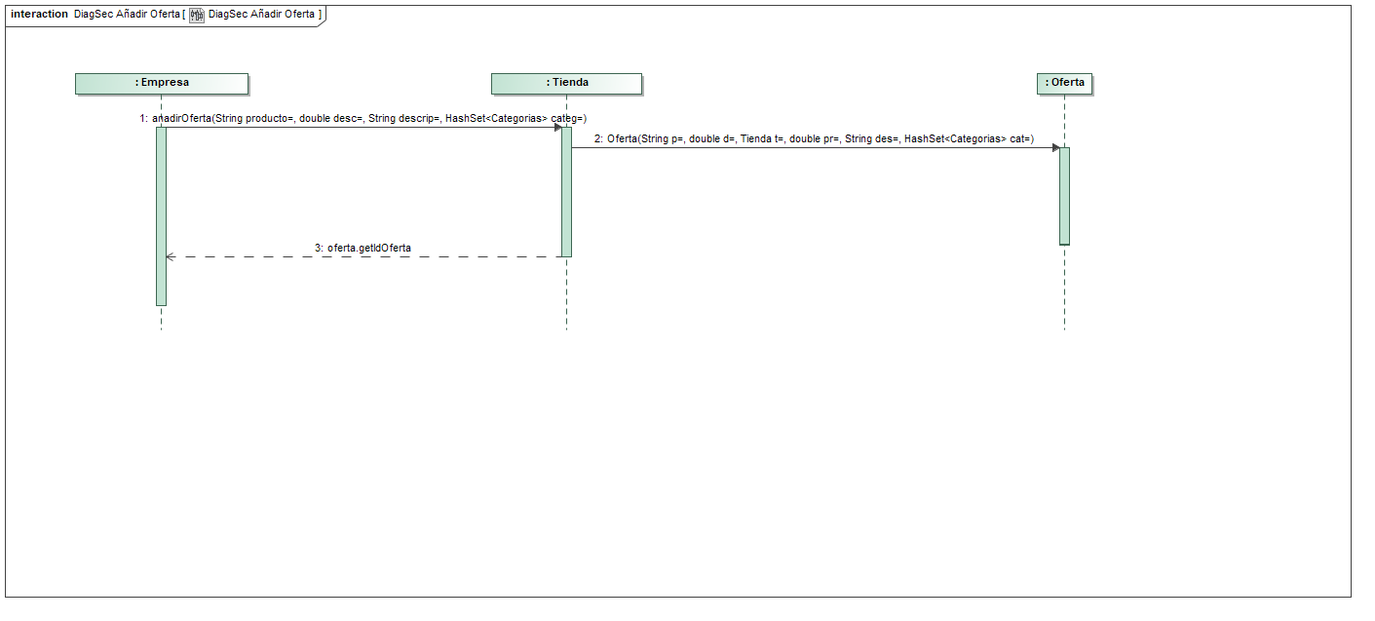

1. DiagSec Añadir Oferta

## DiagSec Búsqueda

NA

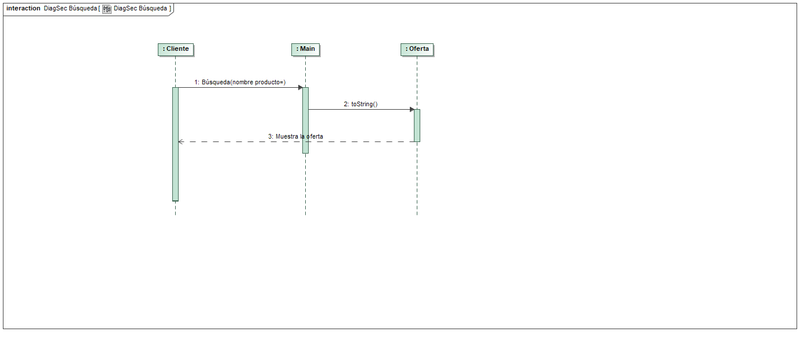

1. DiagSec Búsqueda

## DiagSec Compartir oferta

NA

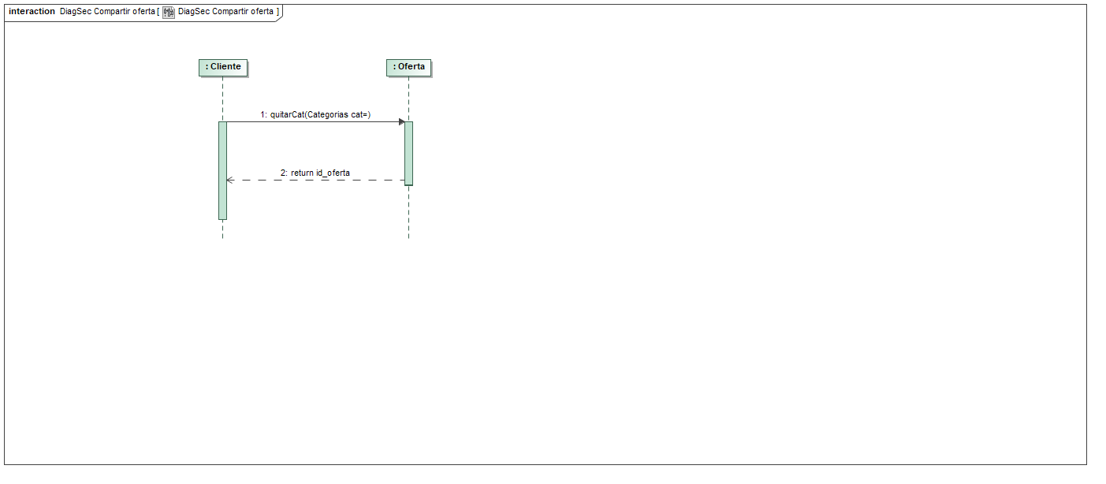

1. DiagSec Compartir oferta

## DiagSec Crear Tienda

NA

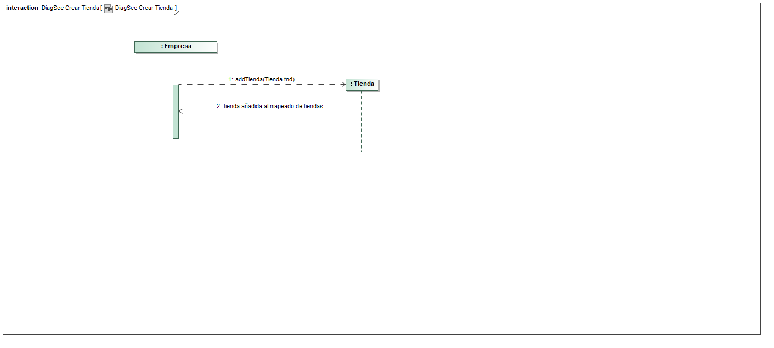

1. DiagSec Crear Tienda

## DiagSec Login

NA

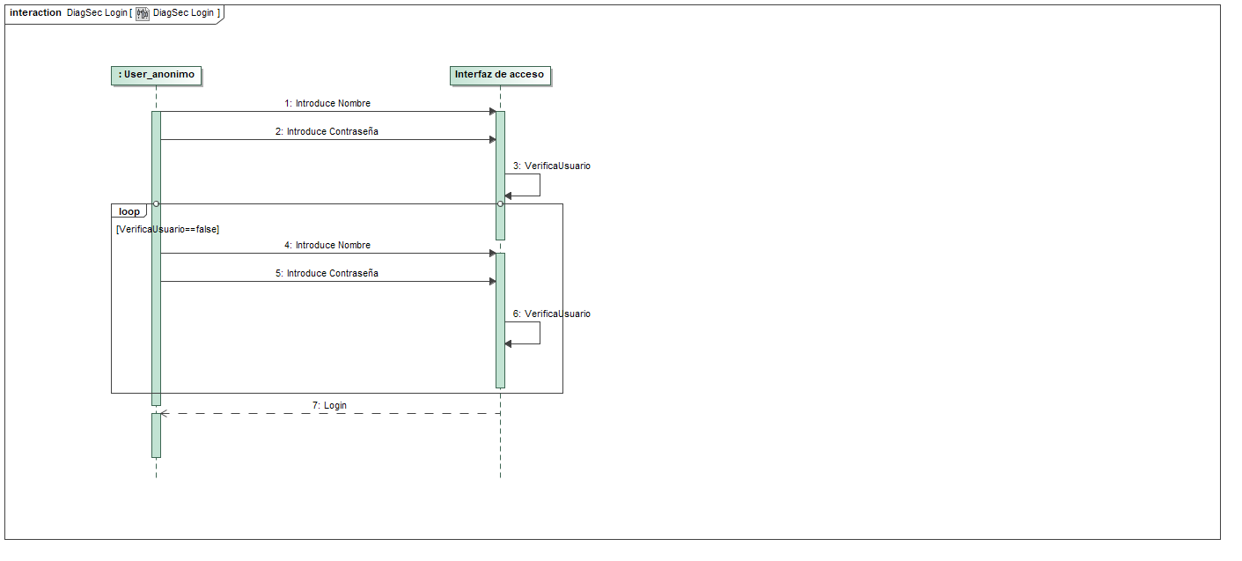

1. DiagSec Login

## DiagSec Opinión ofertas

NA

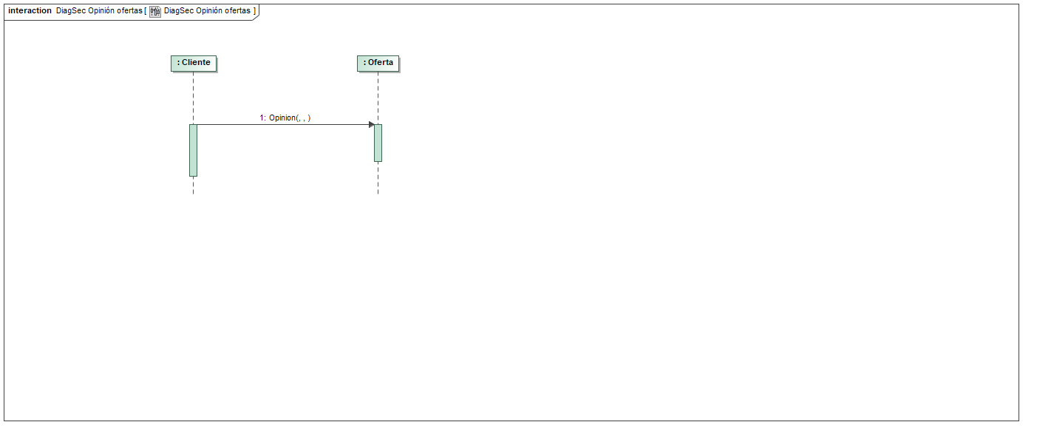

1. DiagSec Opinión ofertas

## DiagSec Opinión tiendas

NA

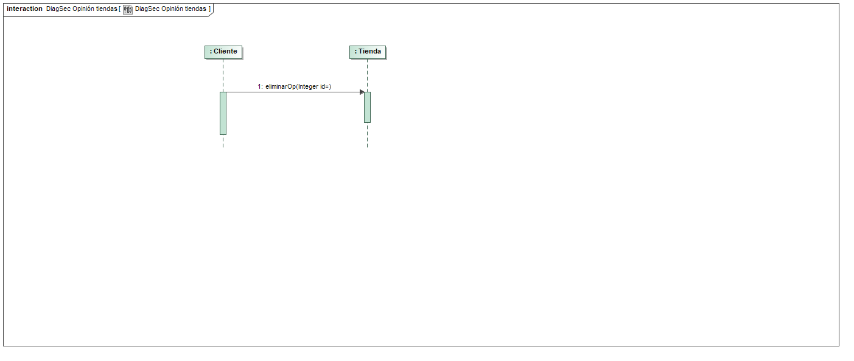

1. DiagSec Opinión tiendas

## DiagSec Quitar Oferta

NA

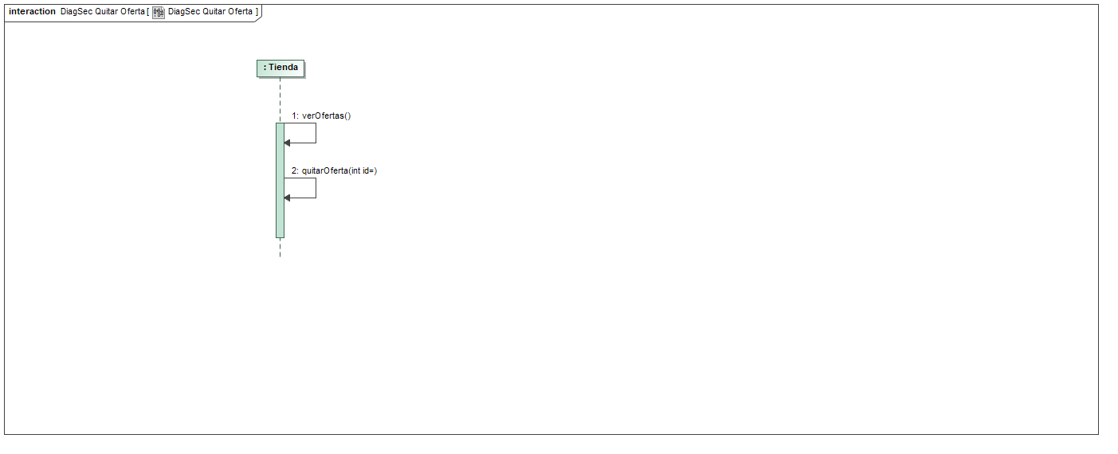

1. DiagSec Quitar Oferta

## DiagSec Quitar Opinion

NA

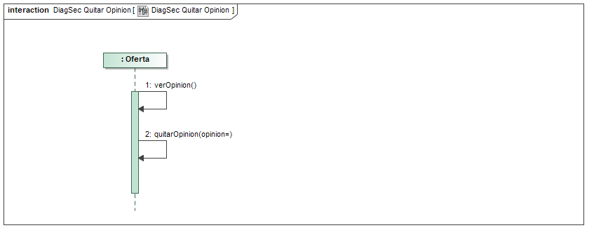

1. DiagSec Quitar Opinion

## DiagSec Quitar Tienda

NA

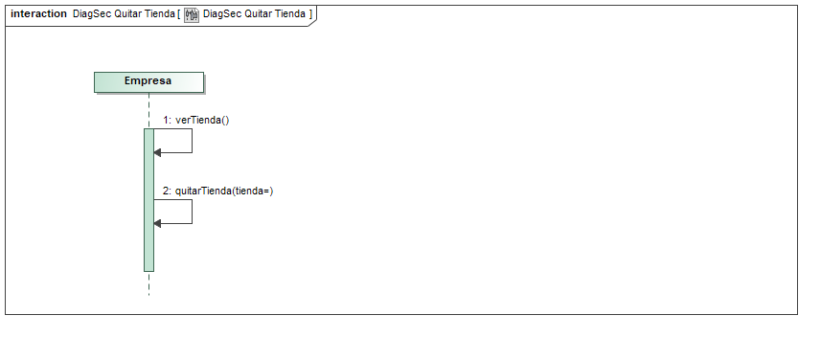

1. DiagSec Quitar Tienda

## DiagSec Registro

NA

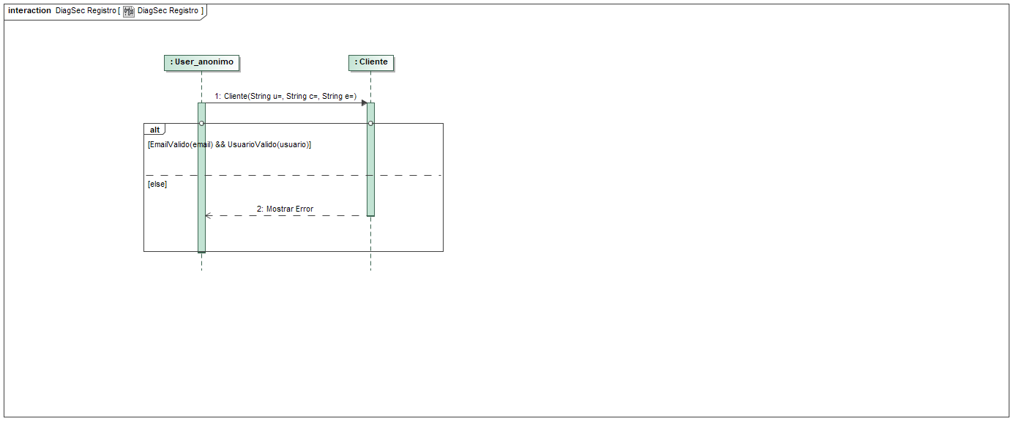

1. DiagSec Registro

## Domain model

NA

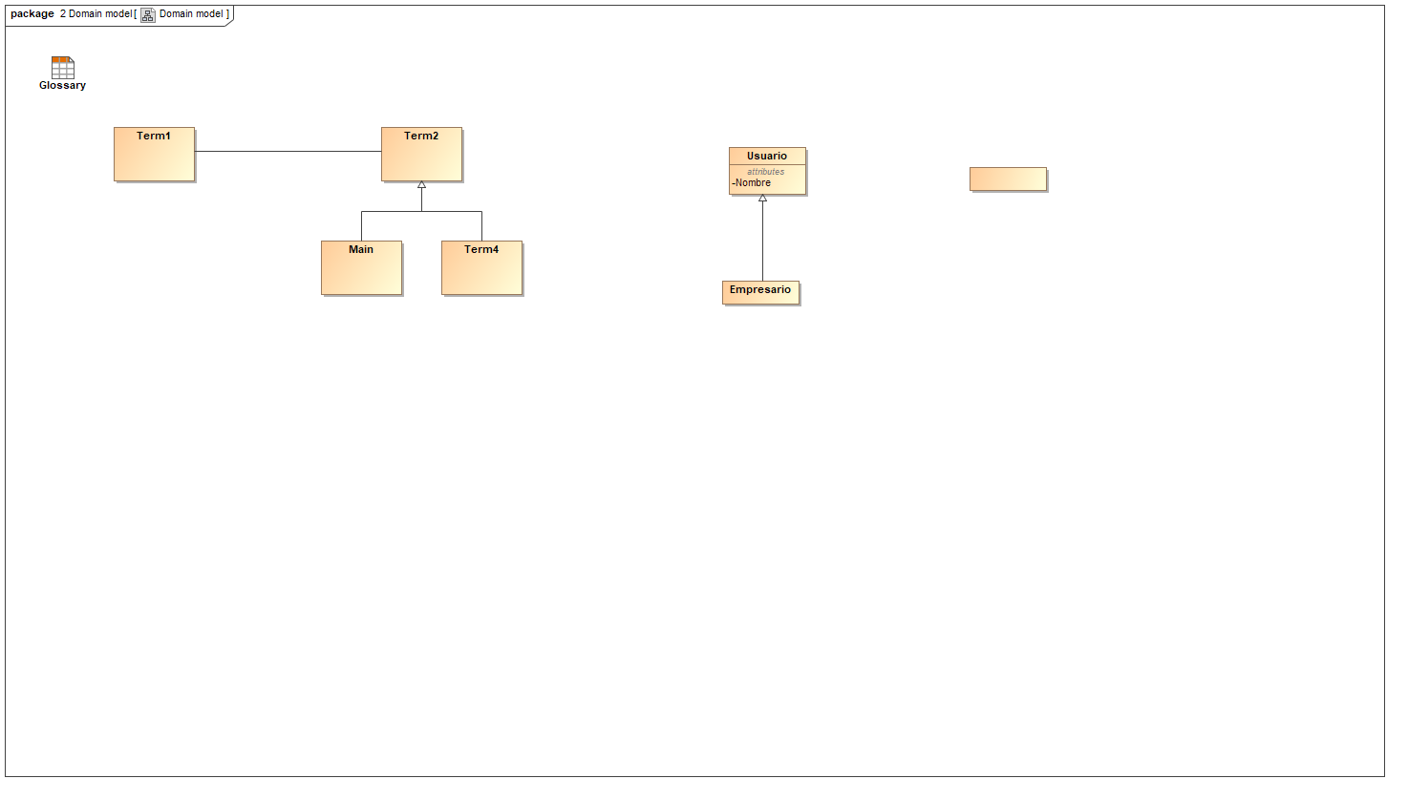

1. Domain model

## Flow

NA

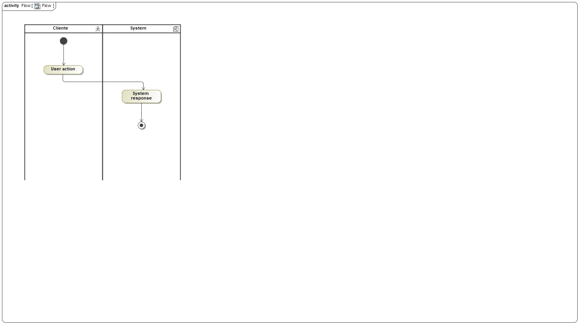

1. Flow

## Flow

NA



1. Flow

## Flow

NA



1. Flow

## FR diagram

NA

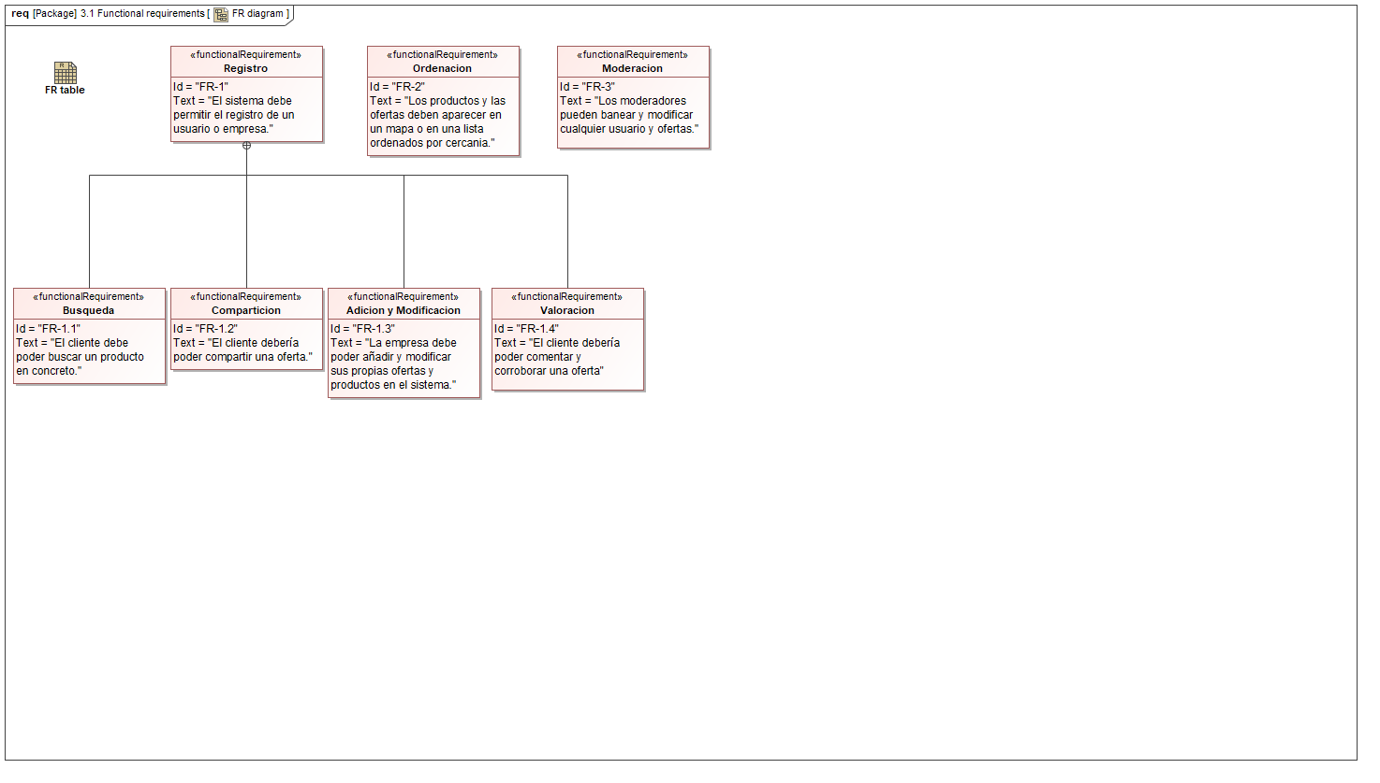

1. FR diagram

## FR table

NA

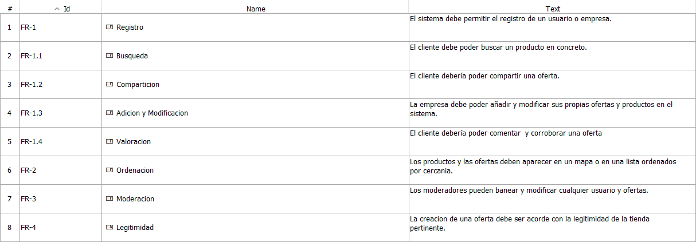

1. FR table

## Full traceability

NA

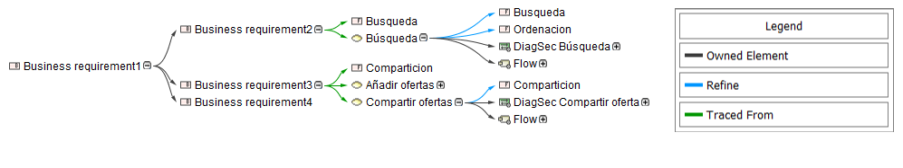

1. Full traceability

## Glossary

NA

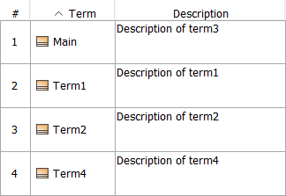

1. Glossary

## Intro

NA

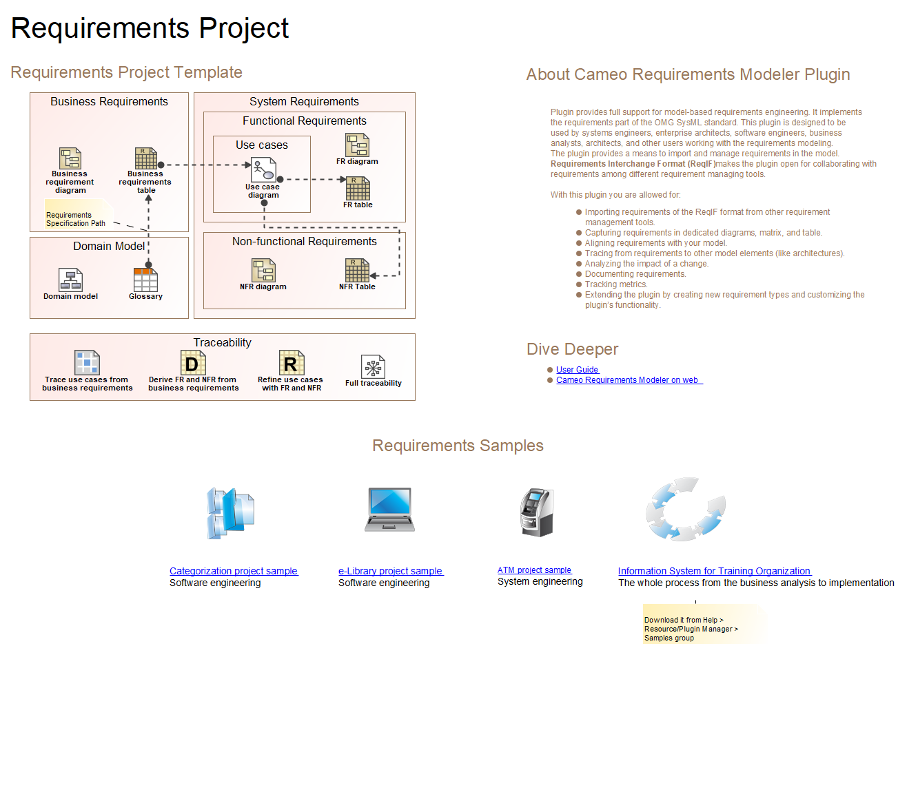

1. Intro

## NA

NA

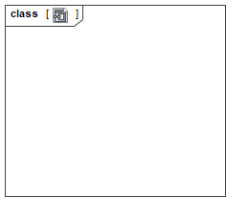

1. NA

## NFR diagram

NA

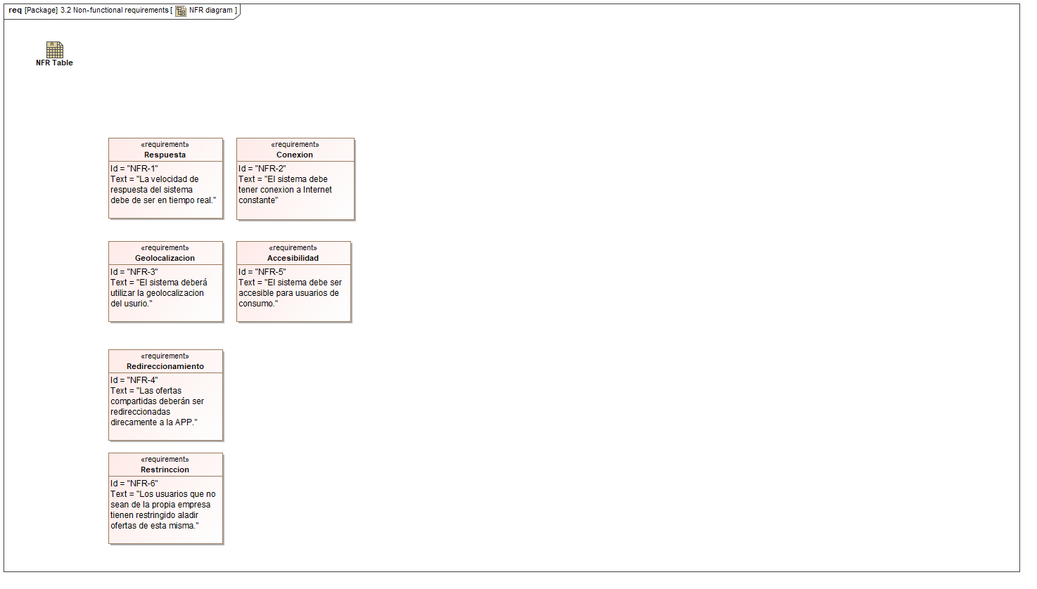

1. NFR diagram

## NFR Table

NA

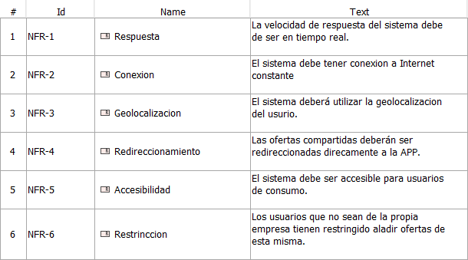

1. NFR Table

## Refine use cases with FR and NFR

NA

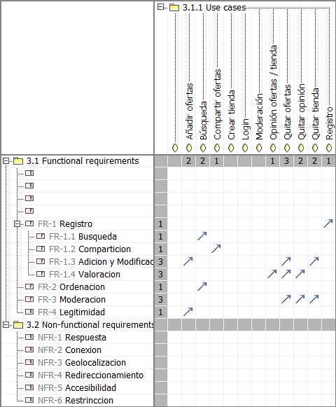

1. Refine use cases with FR and NFR

## Trace use cases from business requirements

NA

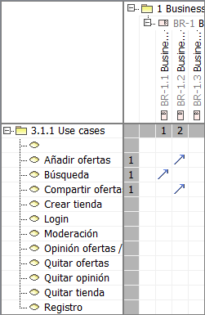

1. Trace use cases from business requirements

## Untitled1

NA

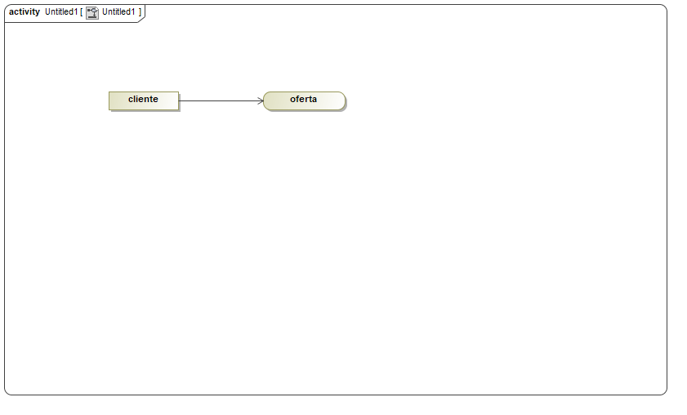

1. Untitled1

## Use case diagram

NA

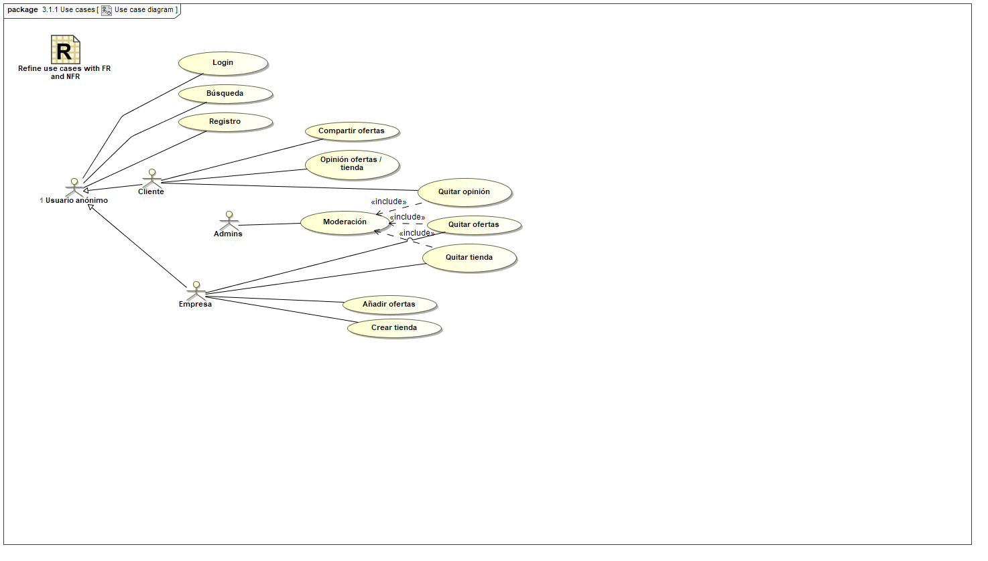

1. Use case diagram